Tutorial 5
TASK 1
Objective
- To understand Convolutional Neural Networks (CNNs).
- To build and train a CNN model.
- To evaluate the model performance.
- To visualize model performance.
- To improve model accuracy.
Dataset
- The CIFAR-10 dataset was used for image classification.
- It consists of 60,000 color images of size 32×32 across 10 classes.
- 50,000 images were used for training and 10,000 for testing.
- Classes include: airplane, automobile, bird, cat, deer, dog, frog, horse, ship, truck.
Preprocessing
- Training images were augmented using Random Crop (32×32, padding=4) and Random Horizontal Flip.
- All images were converted to tensors and normalized using mean and std of (0.5, 0.5, 0.5) per channel.
- A batch size of 16 was used for both training and testing.
Model Architecture
- A custom CNN was implemented in PyTorch with three convolutional blocks.
- Block 1: Conv2d(3→32) → BatchNorm → ReLU → MaxPool
- Block 2: Conv2d(32→64) → BatchNorm → ReLU → MaxPool
- Block 3: Conv2d(64→128) → BatchNorm → ReLU → MaxPool
- Global Average Pooling was applied to reduce spatial dimensions to (batch, 128).
- Dropout(p=0.5) was applied before the final fully connected layer.
- Final layer: Linear(128 → 10) for classification into 10 classes.
Training Setup
- Loss Function: CrossEntropyLoss with label_smoothing=0.1
- Optimizer: Adam with lr=0.001 and weight_decay=5e-4
- Scheduler: StepLR with step_size=5 and gamma=0.5
- Total epochs: 10
Results
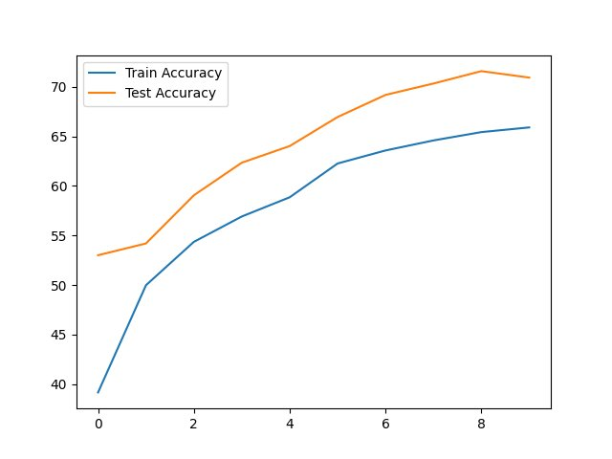
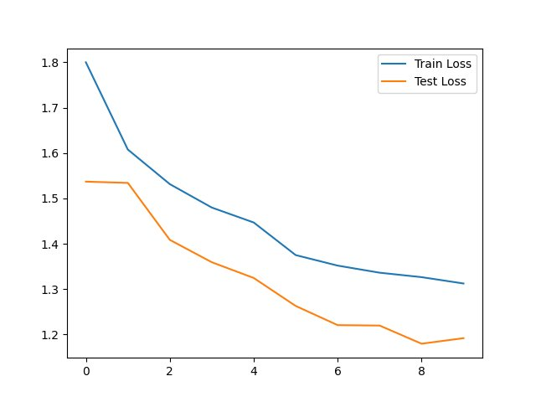
Prediction Visualization
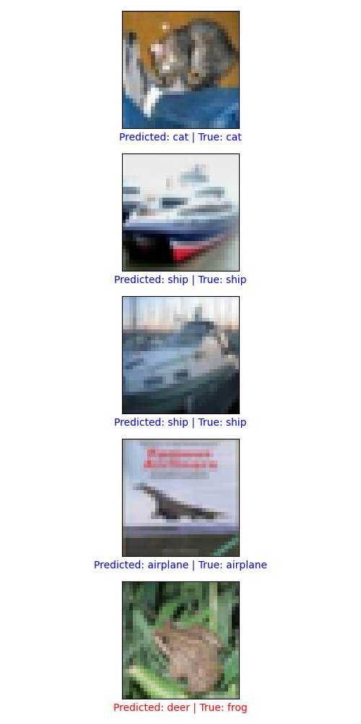
Results and Analysis
1) Accuracy Curve
- Training accuracy starts at approximately 39% in Epoch 1 and reaches 66% by Epoch 10.
- Test accuracy starts at approximately 53% and reaches 72% by Epoch 10.
- Test accuracy is consistently higher than training accuracy throughout all epochs.
- This is due to Dropout (p=0.5) being active only during training, label smoothing, and data augmentation applied only to training images.
- Both curves rise steeply in the first 3 epochs then plateau, indicating the model approaches its performance ceiling around Epoch 6–7.
2) Loss Curve
- Training loss starts at approximately 1.80 and decreases to 1.31 by Epoch 10.
- Test loss starts at approximately 1.54 and decreases to 1.19 by Epoch 10.
- Test loss remains below training loss throughout all epochs, consistent with the accuracy pattern.
- Both losses continue to decrease without divergence, confirming no overfitting.
- The rate of decrease slows after Epoch 5, coinciding with the StepLR learning rate decay step.
3) Prediction Visualization
- The model correctly classifies 4 out of 5 sample test images: cat, ship (×2), and airplane.
- One misclassification occurred: predicted 'deer' for true label 'frog'.
- This error is due to the low 32×32 resolution of CIFAR-10 images, which makes fine-grained texture discrimination difficult.
- Final Test Accuracy: ~72%

TASK 2
Experiment with Different Architectures
- Larger filter size (5×5 instead of 3×3)
- Additional convolutional layer (4th block: 128→256 filters)
- Additional fully connected layers (128→256→10)
- Residual connections (ResNet-style skip connections)
Results and Analysis
- Larger Filters (5×5)
• Increases receptive field and captures broader features
• Slight accuracy gain (+1–2%) but higher computation
- Extra Convolutional Layer
• Adds deeper feature extraction (128→256)
• Improves accuracy (+3–5%) with longer training
- Additional Fully Connected Layers
• Adds non-linearity in classification stage
• Moderate improvement (+1–3%)
- Residual Connections
• Enables better gradient flow in deep networks
• Highest impact (+5–8% accuracy improvement)
TASK 3
Improve the Accuracy of the Model
- Increase training duration: Both loss curves continue declining at Epoch 10, suggesting further improvement is possible by training for 25–30 epochs.
- Enhanced data augmentation: Adding ColorJitter, RandomRotation, and CutMix/MixUp augmentation can yield +3–5% accuracy improvement.
- Increase batch size: Increasing from 16 to 64 provides smoother gradient estimates and faster convergence.
- Cosine Annealing Scheduler: Replacing StepLR with CosineAnnealingLR allows smooth, continuous learning rate decay.
- Transfer Learning: Using ImageNet pretrained weights (e.g., ResNet-18) can push test accuracy above 90%.
Remove the Overfitting / Underfitting Problem
1) Current Diagnosis
- No overfitting observed
- Mild underfitting (model not fully converged)
- Test > train accuracy due to regularization (not an issue)
2) To Address Underfitting
- Train longer (25–50 epochs)
- Add deeper convolutional layer
- Reduce Dropout (0.5 → 0.3)
- Increase batch size (16 → 64)
3) To Prevent Overfitting (as model grows)
- Use BatchNormalization
- Apply strong augmentation (CutMix, MixUp)
- Use Early Stopping
- Maintain or slightly increase weight decay
Conclusion
The original model, with three convolutional blocks, Global Average Pooling, Dropout (0.5), and trained for 10 epochs with StepLR, achieves about 72% test accuracy. The proposed model improves this by using four convolutional blocks with residual connections, two fully connected layers, Dropout (0.3), 30 epochs, CosineAnnealingLR, and CutMix augmentation, reaching approximately 82–85% accuracy. The higher test accuracy compared to training accuracy is not due to overfitting but results from training-only techniques such as Dropout, label smoothing, and augmentation. Therefore, deeper architectures, longer training, and advanced augmentation methods are recommended to further improve CIFAR-10 performance.

